Assignment 2- Case Study

Stage 3 Lab Activities

SmartCare Domain Modelling
AI OFF -> AI ON -> COMPARE -> VERIFY | 1 hour

A - Requirements Review
Highlight nouns, verbs and business rules in SmartCare v0.2.
Requirement | Concept | State/behaviour | Decision
Functional | Every patient should be stored with a corresponding ID/MRD. | Necessary for patient search in project code. | Accept
Functional | Practitioners should also have a unique identifier (ID) to help patients determine who to consult through web searches. | Necessary for practitioner search in project code. | Accept
Functional | The appointment booking system should perform validation checks to identify booking gaps, cancellations, and scheduling conflicts. | Should specify what will happen when it does check in software code. | Accept
Functional | The system should record data dictionaries of all important medical, GP and booking information for appointment histories. | May need to include different data storage types depending on how the program is. | Modified/Accepted
Functional | The system sends prior notification to practitioners, receptionists, and patients when it shuts down for updates/errors, and it will only do so during non-working hours. | Specify ‘non-working hours’ in the system. | Accepted
Functional | The practitioner will send input to the receptionist with a specific field called item number that will give them the go-ahead to process patient payments. | What code features will be used to make this? | Accepted
Functional | The practitioner can choose the input type for the patient's payment between bulk billing (full cost of services is sent to Medicare to pay (Medicare must be enroll/applied for by an Australian citizen for any consultation)) and direct private payment (A more expensive payment paid by the patient; still includes payment from Medicare but less than bulk bill). | What code features will be used to make this? | Accepted
Functional | The receptionist will check whether the system has received both the item number field sent from the practitioner and the input type from them in relation to the patient payment method. | What code features will be used to make this? | Accepted
Functional | When the patient comes to the receptionist to check in after the appointment, the system will either request them to make a direct private payment or inform them of the successful bulk billing. | How will this information be sent to the receptionist through the system? | Accepted
Functional | After making a direct private payment, the system will send the patient a financial receipt to confirm the payment method. | Through email or as a PDF, what format will it be? | Accepted

B - Candidate Classes
Record candidate concepts, supporting requirements, state and behaviour.
Candidate | Class? | Reason
Patient | String/Int(ID) | How each of these is displayed. Needs patient details and ID locator.
Practitioner | String/Int(ID) | How each of these is displayed. Needs practitioner details and ID locator.
Appointment | Datetime | How each of these is displayed. Is not classified as a data type but uses a module.
Name | String | How each of these is displayed. Name values are typically strings.
Clinic | String | How each of these is displayed. Clinic name only needs to be a string.
Database | MySQL | How each of these is displayed. Most mainstream language for database creation.
Cancellation | Input Type | How each of these is displayed. Only needs to offer input, not classify data types.
Status | On Interface | How each of these is displayed. Needs to be shown instead.

C - CRC Cards
Create CRC cards for Patient, Practitioner and Appointment.

Patient
Responsibilities | Collaborators
Patient ID | Practitioner
Patient MRN | Receptionist
Patient First Name/Last Name | Medical Record
Private/Viewable Medical Record
Book Consultation Session
View Practitioner Information

Practitioner
Responsibilities | Collaborators
Practitioner ID | Patient
Process Payment Items | Receptionist
Practitioner First Name/Last Name | Medical Notes
Viewable Patient Medical Record | Practice Manager
View Scheduled Bookings
Patient diagnosis

Appointment
Responsibilities | Collaborators
Patient/Practtioner ID/or MRN | Patient
Book Consultation Session | Practitioner
Practitioner First Name/Last Name | BestPractice System
Patient First Name/Last Name | Practice Manager
View Scheduled Bookings

Payment
Responsibilities | Collaborators
Processed Payment Items | Receptionist
Item Number | Practioner
Bulk Billing/Direct Private Payment Options | Medical Provider
System message to receptionist | Bank Details

D - UML Model
Draw classes, attributes, operations, associations and multiplicities.
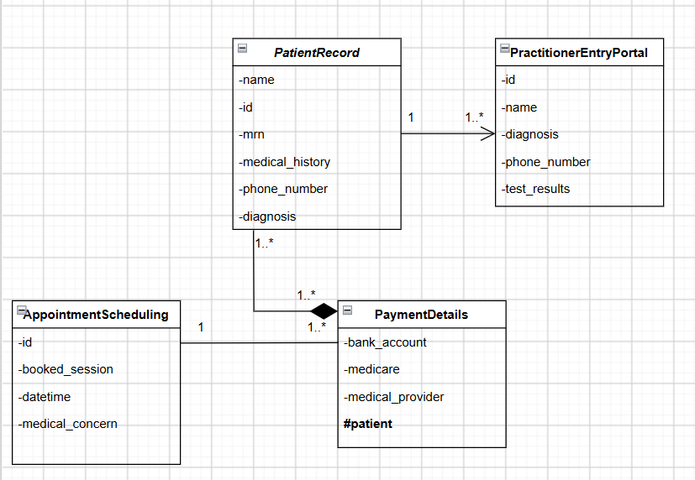

E - AI Design Review
Ask AI to suggest classes and relationships using only confirmed requirements; require supporting requirement IDs.

F - Compare and Decide
Record at least one accepted, modified and rejected AI suggestion.

AI suggestion | Evidence | Decision | Reason | Model change
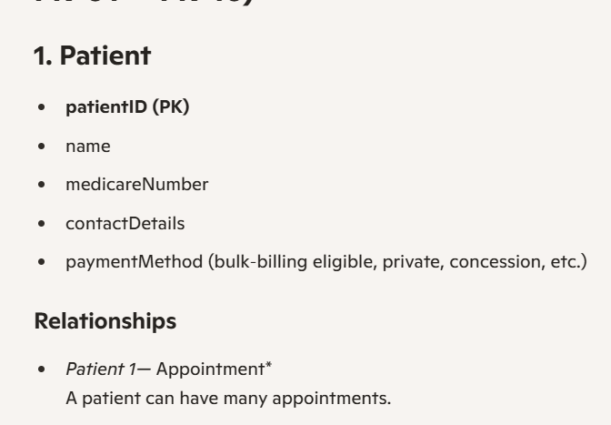  Figure 1 Copilot AI Prompt | Based on the system BestPractices, they leave the payment method entirely up to the practitioners' decision-making. | Rejected/Modified | The paymentMethod class should not be there, as the paymentMethod is not derived from the patient but the practitioner. | Changing it to reflect the patient's medical background and/or diagnosis would be a good consideration.
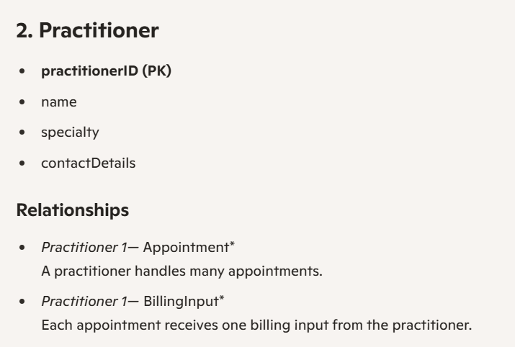  Figure 2 Copilot AI Prompt | Every practitioner has their own specialty, whether that is a dentist or a GP, etc. | Accepted | Including the addition of the practitioner’s specialty was a good consideration. Relationships are well defined. | More on the features they have access to would be informative.
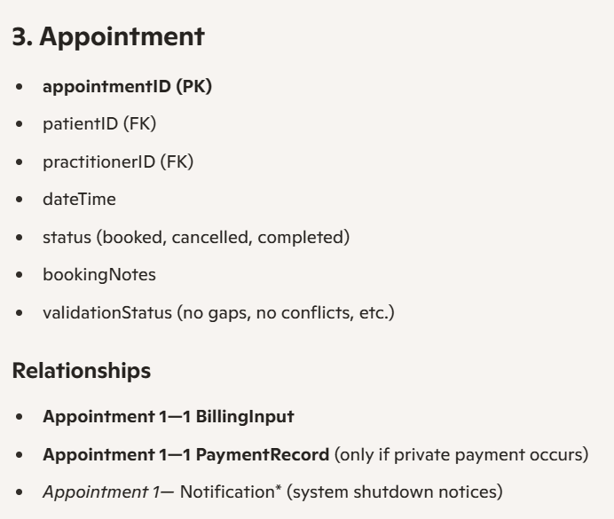  Figure 3 Copilot AI Prompt | The BestPractice System would have to have the datetime and/or status/booking notes. | Accepted | The change from medical concern to booking notes is better, as it allows more flexibility from the patient's perspective. | There is nothing to change.
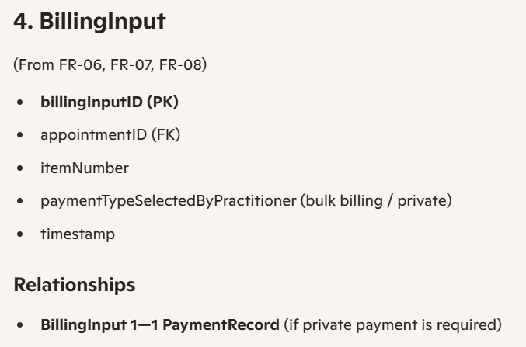  Figure 4 Copilot AI Prompt | According to the analysis on the BestPractice System, there are two billing types, meaning there should be a portal for this function. | Accepted | BillingInput has all the necessary classes like ItemNumber and paymentTypeSelectedByPractitioner. | There is nothing to change.
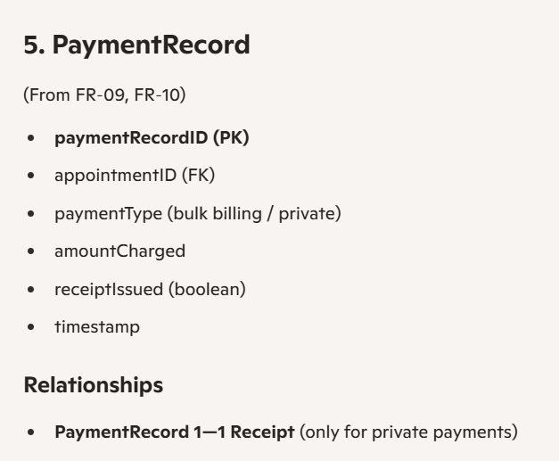  Figure 5 Copilot AI Prompt | The functional requirements specified the need for a receipt. | Accepted/Modified | Is good, but it is not necessary to have paymentType. | Should get rid of paymentType and instead focus on the other classes and how they work.

G - Python Skeletons
Create simple Patient, Practitioner and Appointment class skeletons.

H - Consistency Check
Check model-code consistency; do not implement full behaviour yet.
Pseudo Code:
Payment:
If practitioner == sent_ItemNumber then:
Receptionist asks for input for bank account details/payment

Reflection
What modelling decision was hardest? Where did AI over-design? What evidence supported your final choices?
They overdid the payment options, likely because of their convoluted nature in the system.

